Brushless DC Motors (BLDC)

Brushless DC motors have gained popularity in the drone industry due to their improved efficiency and reliability. Unlike brushed motors, they don't have physical brushes that wear out over time.
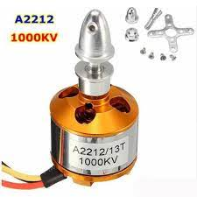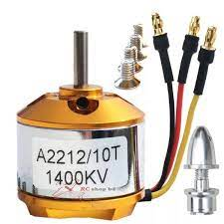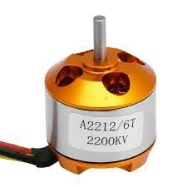

In the market there are different types and different size for drone brushless motor.
Here we can find the motor details to show their body sill.
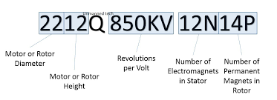

Here 10T, 13T 6T represent the torque of the motor. For racing drone we need to high KV motor. But in out AI base camera drone need a below 1000kv Brushless motor due to high torque required
- So we need below 100KV or near 1000Kv BLDC Motor.
Motor KV | Torque
1000kv | 13
1400kv | 10
2200kv | 6

The showed Yellow brushless motor is non brand so many problems can happened.
Problems of Yellow motor
SL.N | Problems of Yellow Motor
1 | Over Heat issue
2 | Motor can burn
3 | Not long lusting
4 | Magnet can removed while running in the air
5 | Low quality magnate Used

Here I select Four Motor for our Drone. Those motor details in below

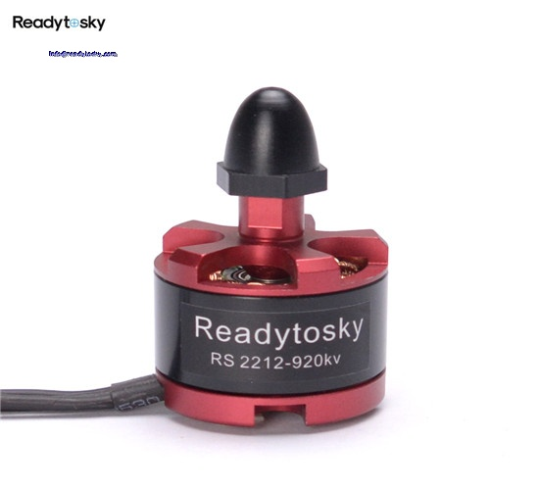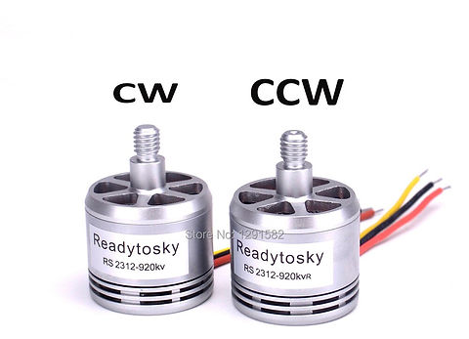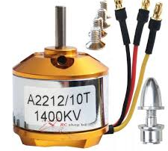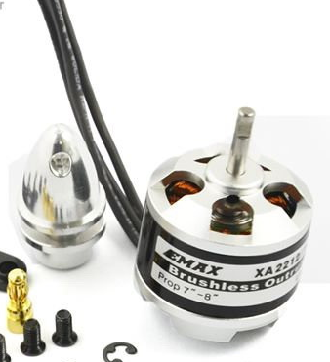

1. DJI 2212 920kv Brushless Motor:
From those four motor it is one of the best budget and best usable in our drone.
Features:
DJI 2212/920KV
Dimension : 28X24mm
Rating : 920kv
Battery :3S,4S
Shaft : 8.0mm
Weight : 56g (with Prop Adapter)
Standard Current : 15-25A
Max Current : 30A
Recommended prop : Li-Poly (11.1V) : 10×4.5
Li-Poly (14.7V) : 8X4.5

Dimensions: 7 x 5 x 1.25 in
Max Power: 370W
Max Thrust: 1200g
2. Emax XA2212 980KV Brushless Motor:
X2212 980KV
KV (rpm/v): 980
Diameter: 28.5mm
Shaft Diameter: 3mm
Length: 44mm
Lipo Battery (cell): 2S-3S Li-poly
Color: Silver
Weight: 74g
Suitable propellers Dimension: 10×4.7,9×6
MAX Thrust: 880g
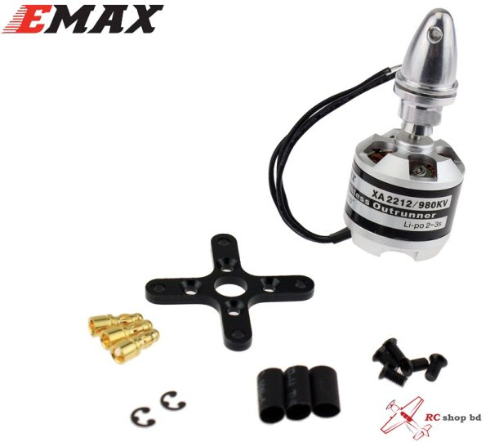
3. A2212 1000Kv Brushless Motor:
Model: A2212
RPM/V: 1000KV.
Batteries: 2-3 Li-Poly.
Efficiency: 80%.
Current: 4-10A (at 75%).
No-load current: 10V/0.5A.
Max. Transient current: 12A/the 60S.
Shaft diameter: 3.17mm.
Dimensions: 27.5*28mm.
3.17mm Propeller mount incl.
Thrust: 11.1v 10×4.5 prop 745 gram
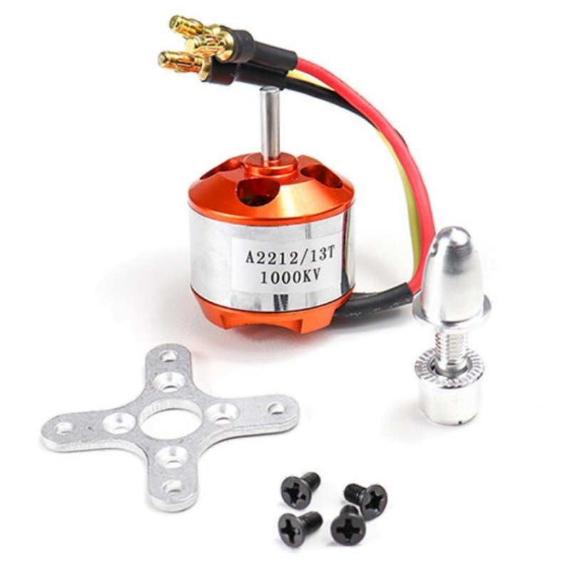

4. DJI 2312A 800KV Motor/ DJI Phantom 3 Engine:
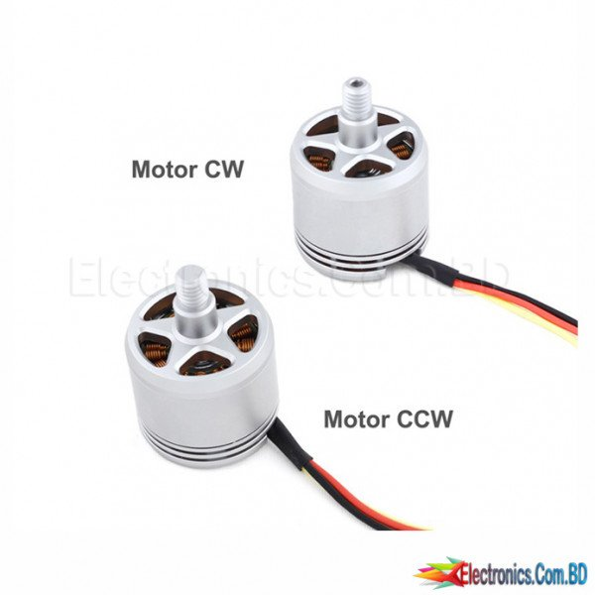
Item Description:
Item name: 800KV CW/CCW Brushless Motor
KV value:KV800KV
Weight: About 53g
Suitable for: For DJI Phantom 3

Features:
– Adopt integral motor shaft design, more effectively protect the motor shaft.
– A new type of impeller seat design is adopted, the performance is more stable, and the disassembly is more convenient.

Here is the all selected BLDC motor Data sheet with their price.
Motor Name | Max thrust |  | Motor Weight | Price | By link
DJI 2212 920kv Brushless Motor |  | 1200g | 56g | 700-800/- | 1. https://www.electronics.com.bd/drones-rc-hobby-accessories/motors/DJI-2212-920KV-Brushless-Motor-2-Pieces-CW-CCW-DJI-2212-920KV-Brushless-Motor-Brushless-Motor-price-in-online-BD-Bangladesh  2. https://rcproductbd.com/product/dji-2212-920kv-brushless-motor/  3. https://www.rcshopbd.com/product/dji-2212-920kv-brushless-motor-cw-ccw/
Emax XA2212 980KV Brushless Motor |  | 880g | 74g | 1100-1400/- | 1. https://www.rcshopbd.com/product/emax-xa2212-brushless-motor-980kv/  2. https://www.electronics.com.bd/emax-xa2212-1400kv-outrunner-brushless-motor-parts-ic-module-sensor-arduino-transistor-resistor-capacitor-robotics-project-electronics?search=EMAx&description=true
A2212 1000Kv Brushless Motor |  | 745g | 47g | 470-550/- | 1.https://www.rcshopbd.com/product/a2212-13t-1000kv-brushless-motor/  2. https://radiogearbd.com/product/1000kv-brushless-outrunner-bldc-motor-a2212/
DJI Phantom 3 Engine |  | 850g | 53g | 650-800/- | 1.https://www.electronics.com.bd/phantom3-motor  2. https://www.rcshopbd.com/product/2pcs-original-dji-2312a-800kv-motor-cwccw/  3. https://rcproductbd.com/product/original-dji-phantom-3-motor-2312a-cw-ccw/

